DFA Design for C source De-Comment Program

Delivered**:** Tuesday December 31, 2019

**Team** {

Yophthahe Amare : ATR/2890/10,

Michael Zewdu : ATR/9935/10,

Hannah Girma : ATR/3076/10

}

On the following page can be found the DFA design diagram that our team designed to implement the program specification provided.

State transition actions and some special states were represented graphically for the purpose of clarity and efficiency and appropriate legend has been provided to decode their meaning.

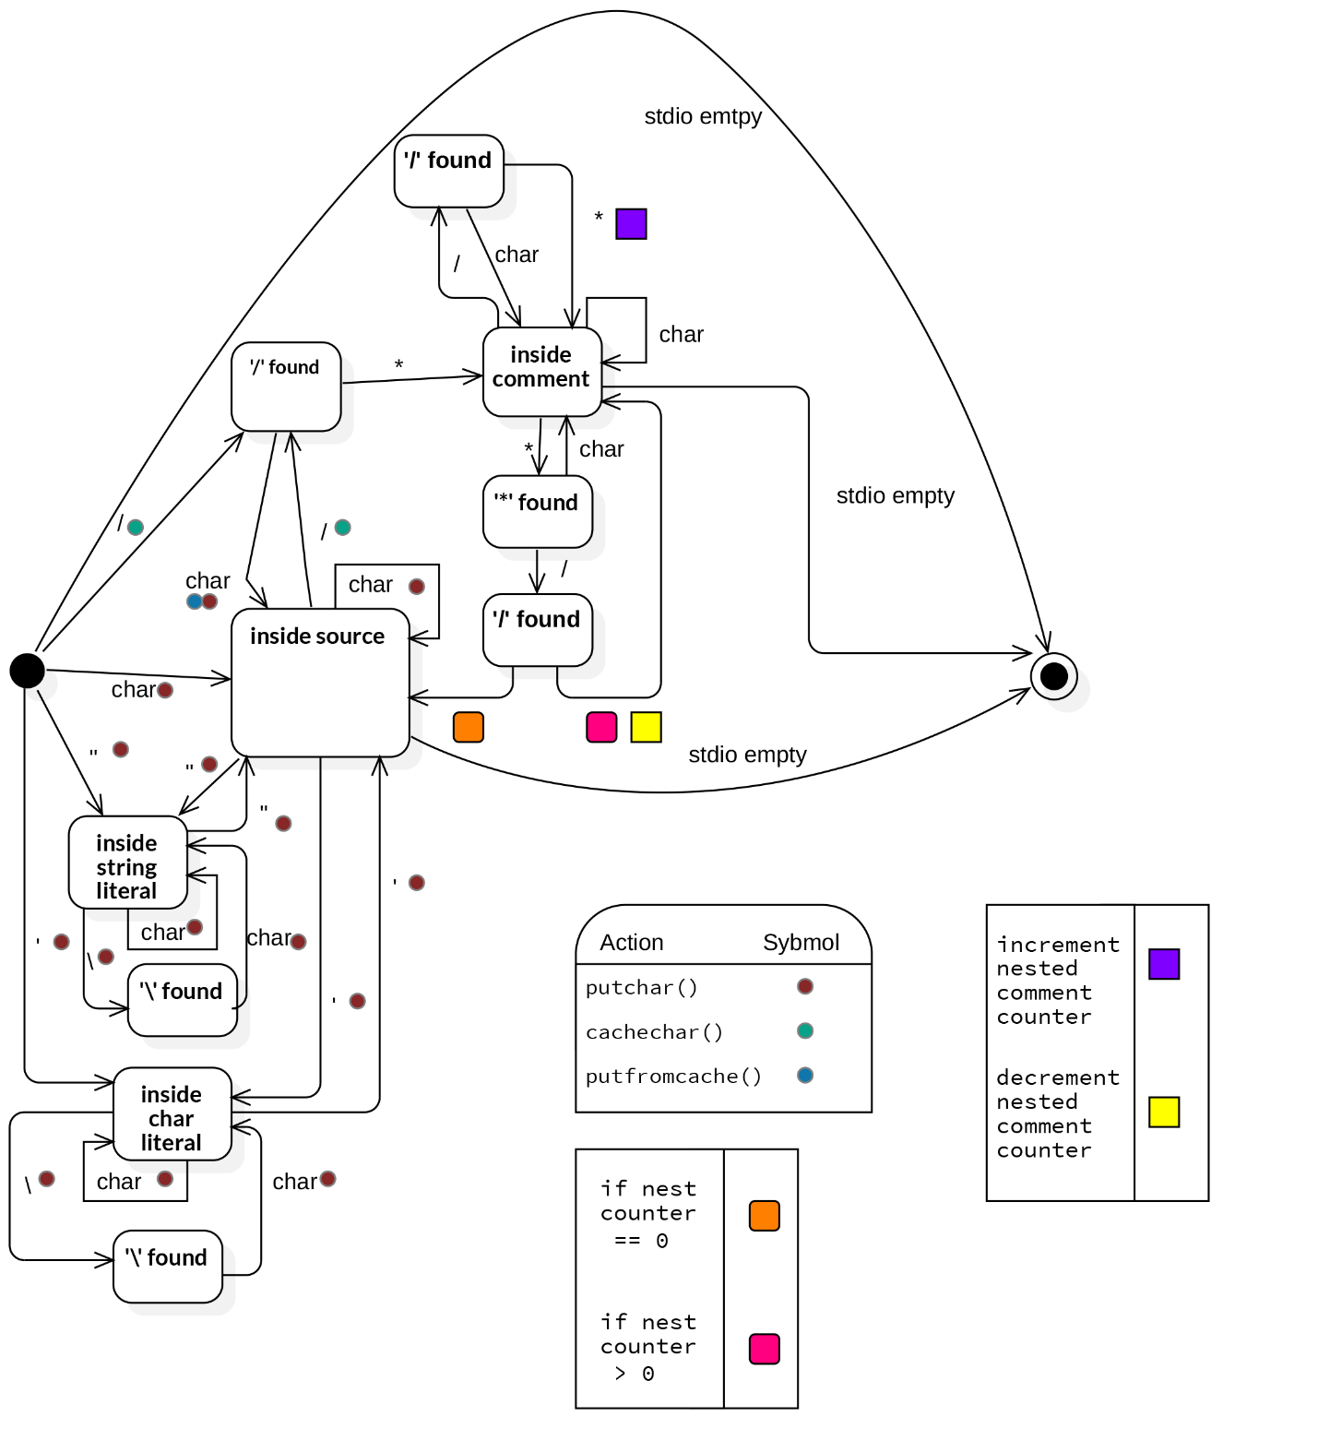

Note:

* The completely black oval at the left of the diagram denotes the starting state of the program and expects the string input from the stdio.
* The outlined black oval at the right edge denotes the end of the program.
* inside source state denotes the automaton is currently traversing C program code strings.
* cachechar() places a single character into a cache.
* putfromcache() retrieves a character from cache and calls putchar() with it.